**Subject:** Artificial Intelligence

**Introduction to Colab:**

You will quickly learn and use Google Colab if you know and have used Jupyter notebook before. Colab is basically a free Jupyter notebook environment running wholly in the cloud. Most importantly, Colab does not require a setup, plus the notebooks that you will create can be simultaneously edited by your team members – in a similar manner you edit documents in Google Docs. The greatest advantage is that Colab supports most popular [machine learning libraries](https://colab.research.google.com/notebooks/intro.ipynb) which can be easily loaded in your notebook.

**What Colab Offers You?**

As a developer, you can perform the following using Google Colab;

* Write and execute code in Python
* Create/Upload/Share notebooks
* Import/Save notebooks from/to Google Drive
* Import/Publish notebooks from GitHub
* Import external datasets
* Integrate PyTorch, TensorFlow, Keras, OpenCV
* Free Cloud service with free GPU

**Creating Folder on Google Drive:**

Since Colab is working on your own Google Drive, you first need to specify the folder you’ll work in. Give the folder a name on your Google Drive. You can use a name or choose the default Colab Notebooks folder instead of the named folder.

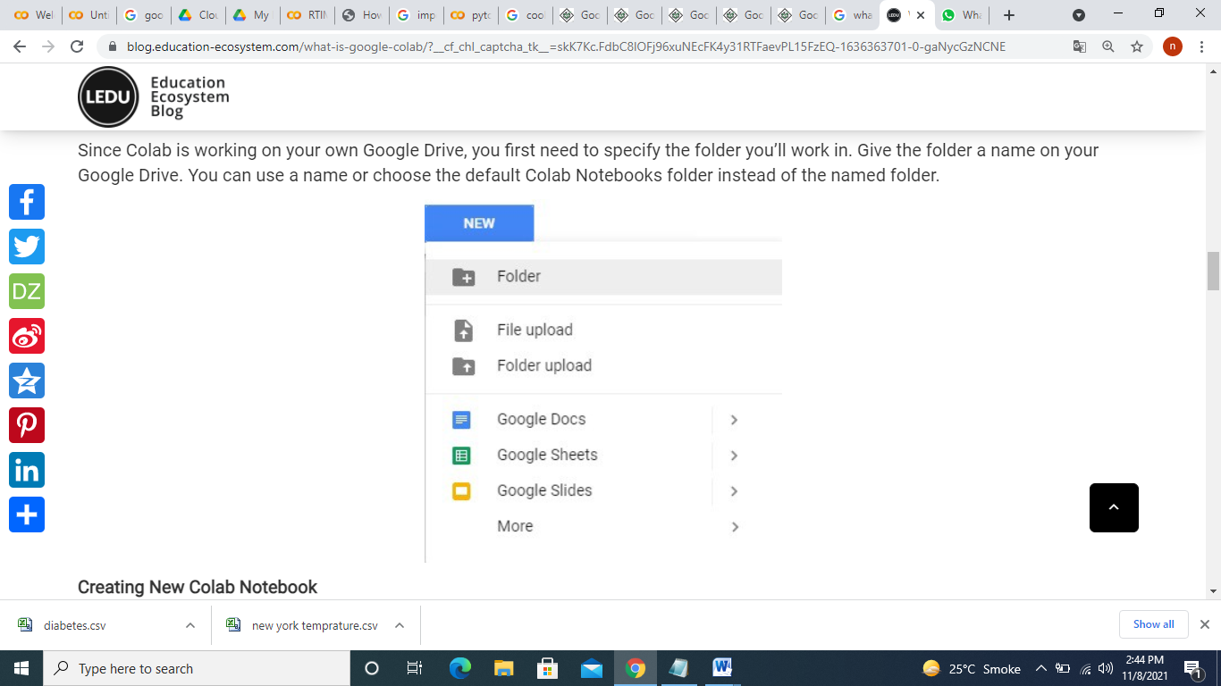

**Creating New Colab Notebook:**

As Colab implicitly uses Google Drive for storing your notebooks, ensure that you are logged in to your Google Drive account before proceeding further.

**Step 1**: − Open the following URL in your browser − [https://colab.research.google.com](https://colab.research.google.com/notebooks/welcome.ipynb) Your browser would display the following screen (assuming that you are logged into your Google Drive)

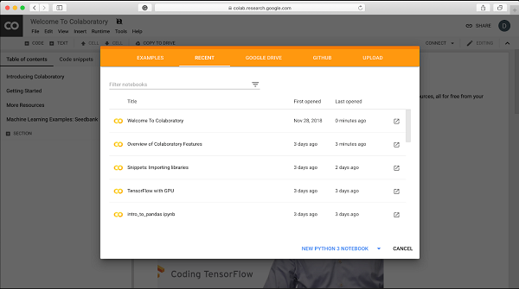

### Step 2 − Click on the NEW PYTHON 3 NOTEBOOK link at the bottom of the screen. A new notebook would open up as shown in the screen below.

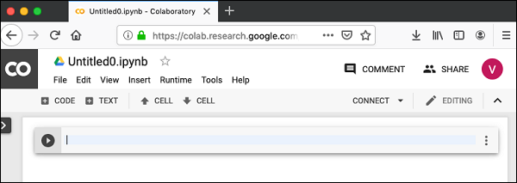

As you might have noticed, the notebook interface is quite similar to the one provided in Jupyter. There is a code window in which you would enter your Python code.

**Setting Notebook Name:**

By default, the notebook uses the naming convention UntitledXX.ipynb. To rename the notebook, click on this name and type in the desired name in the edit box as shown here −

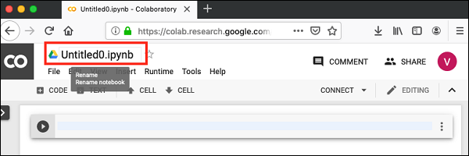

We will call this notebook as MyFirstColabNotebook. So type in this name in the edit box and hit ENTER. The notebook will acquire the name that you have given now.

Entering Code

You will now enter a trivial Python code in the code window and execute it.

Enter the following two Python statements in the code window −

import time

print(time.ctime())

**Executing Code:**

To execute the code, click on the arrow on the left side of the code window.

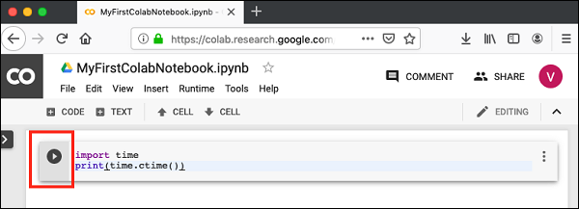

After a while, you will see the output underneath the code window, as shown here −You can clear the output anytime by clicking the icon on the left side of the output display.

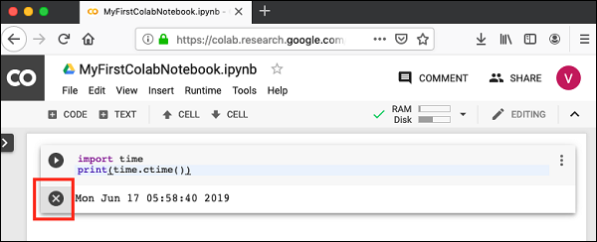

**Adding Code Cells:**

To add more code to your notebook, select the following menu options −

**Insert / Code Cell:**

Alternatively, just hover the mouse at the bottom center of the Code cell. When the CODE and TEXT buttons appear, click on the CODE to add a new cell. This is shown in the screenshot below −

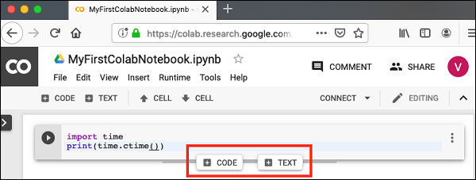

A new code cell will be added underneath the current cell. Add the following two statements in the newly created code window −

time.sleep(5)

print (time.ctime())

Now, if you run this cell, you will see the following output –

Certainly, the time difference between the two time strings is not 5 seconds. This is obvious as you did take some time to insert the new code. Colab allows you to run all code inside your notebook without an interruption.

**Run All:**

To run the entire code in your notebook without an interruption, execute the following menu options −

Runtime / Reset and run all…

It will give you the output as shown below −

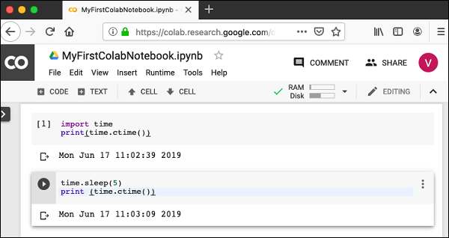

Note that the time difference between the two outputs is now exactly 5 seconds.

The above action can also be initiated by executing the following two menu options −

Runtime / Restart runtime…

or

Runtime / Restart all runtimes…

Followed by

Runtime / Run all

Study the different menu options under the Runtime menu to get yourself acquainted with the various options available to you for executing the notebook.

**Changing Cell Order:**

When your notebook contains a large number of code cells, you may come across situations where you would like to change the order of execution of these cells. You can do so by selecting the cell that you want to move and clicking the UP CELL or DOWN CELL buttons shown in the following screenshot −

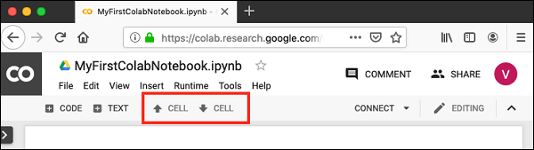

You may click the buttons multiple times to move the cell for more than a single position.

**Deleting Cell:**

During the development of your project, you may have introduced a few now-unwanted cells in your notebook. You can remove such cells from your project easily with a single click. Click on the vertical-dotted icon at the top right corner of your code cell.

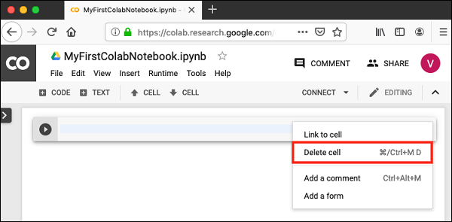

Click on the Delete cell option and the current cell will be deleted.

**Google Colab Saving Your Work:**

Colab allows you to save your work to Google Drive or even directly to your GitHub repository.

**Saving to Google Drive:**

Colab allows you to save your work to your Google Drive. To save your notebook, select the following menu options −

**File / Save a copy in Drive…**

You will see the following screen −

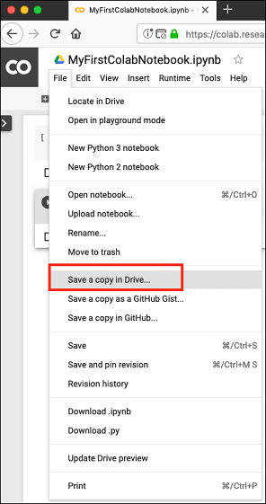

The action will create a copy of your notebook and save it to your drive. Later on you may rename the copy to your choice of name.

**Saving to GitHub:**

You may also save your work to your GitHub repository by selecting the following menu options −

File / Save a copy in GitHub...

The menu selection is shown in the following screenshot for your quick reference −

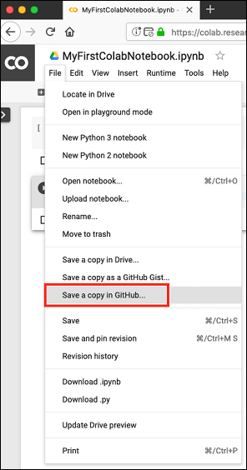

You will have to wait until you see the login screen to GitHub.

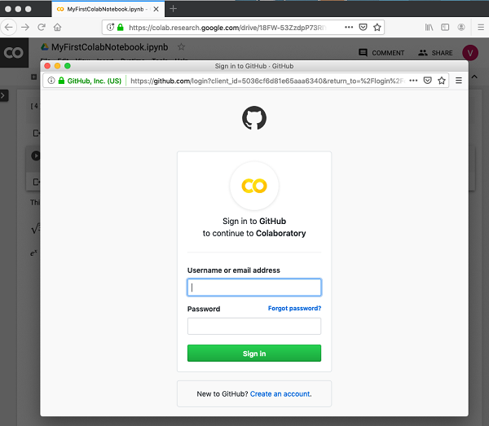

Now, enter your credentials. If you do not have a repository, create a new one and save your project as shown in the screenshot below −

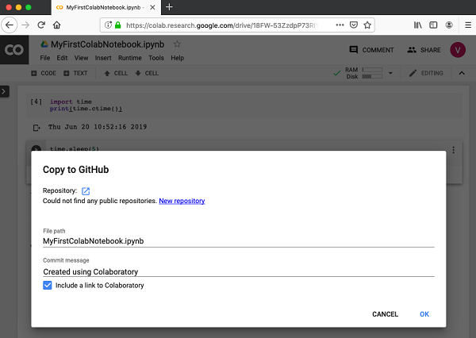

**Google Colab Sharing Notebook:**

To share the notebook that you have created with other co-developers, you may share the copy that you have made in your Google Drive.

To publish the notebook to general audience, you may share it from your GitHub repository.

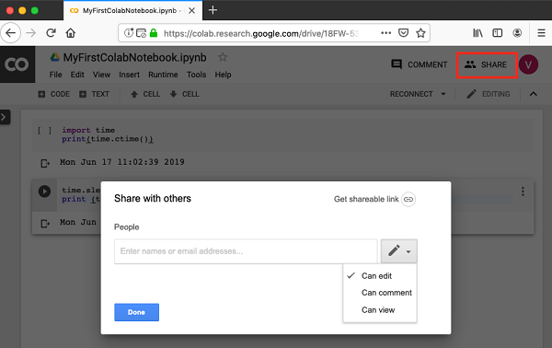

You may enter the email IDs of people with whom you would like to share the current document. You can set the kind of access by selecting from the three options shown in the above screen.

Click on the Get shareable link option to get the URL of your notebook. You will find options for whom to share as follows −

* Specified group of people
* Colleagues in your organization
* Anyone with the link
* All public on the web

## Top Keyboard Shortcuts in Google Colab:

Switching between your keyboard and mouse is a tedious and time taking task. Therefore, to speed things up, Google Colab provides us with certain really useful keyboard shortcuts. Honestly, you can’t master the Colab experience until you’ve used and become acquainted with these keyboard shortcuts.ss Honestly, I feel these keyboard shortcuts increase our productivity as data scientists. I know it takes some time to learn these, but once you do get a hang of them, you can complete your work much faster.

I have created a list of top keyboard shortcuts that you should know when working with Google Colab. These key combinations are what I use, but you can modify them according to whatever is more comfortable:

[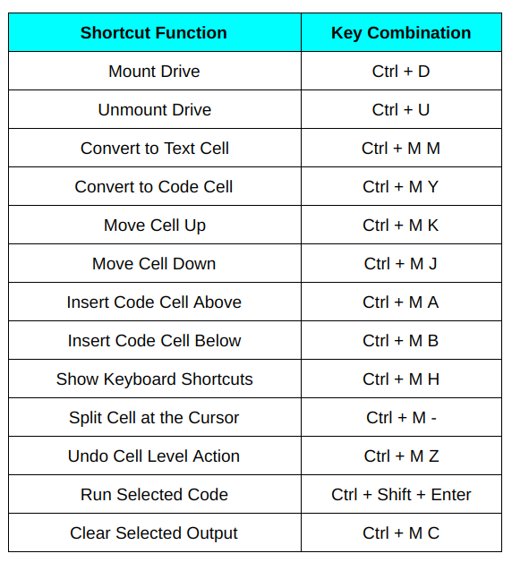](https://cdn.analyticsvidhya.com/wp-content/uploads/2020/03/ct14.png)